Needs Analysis and Design of Martapura Kingdom Numerical Teaching Materials based on Android with the help of I-Spring suite
for Elementary School students in Samarinda City.

Yulian Widya Saputra¹, Kurniawan² , Fitria Nurul Hidayah³, Mujahadah⁴

¹ Lecturer of Geography Education FKIP Mulawarman University Samarinda Indonesia
² Lecturers of Mathematics Education FKIP Mulawarman University Samarinda Indonesia
³ Lecturers of UIN Sultan Aji Muhammad Idris Samarinda Indonesia
⁴ Students of Mathematics Education FKIP Mulawarman University Samarinda Indonesia

Email: ¹yulian.widya@fkip.unmul.ac.id
Abstract

The advantage of the mobile learning concept is that learning can be accessed at any time because it is installed on a smartphone and can be applied to mathematics courses in ethno-mathematics-themed elementary schools. elementary school students in Samarinda City. This research is part of Research and Development (R&D) to develop teaching materials using the ADDIE (Analysis, Design, Development, Implementation, and Evaluation) model. These five stages the researcher uses the Analysis and Design stage. Data collection used a questionnaire filled out by elementary school students and interviews with teachers. The data analysis technique used in this study is a qualitative descriptive data analysis technique and a quantitative descriptive data analysis technique. The research results obtained the results of the stages of needs analysis, from stakeholders and development design. Based on the needs analysis conducted, it was found that 51.6% did not know the oldest kingdom in the archipelago, 19% of learning media still used PowerPoint, 19% visual aids, 20% videos. Regarding gadget or cellphone ownership, 100% of students have their own cellphone and still use it to play online games. The results of the subsequent questionnaire 100% did not know the figure of Raja Mulawarman, 57.1% of students stated that they had never been taught mathematics related to cultural history (ethnomatematics). Teacher interviews in the mathematics learning process tend to use power point and have never used android media. The teacher has never delivered ethnomathematics-based mathematics material. The results of the design stage, the researcher designed math teaching materials (island numbers) based on android applications.

Keywords: Teaching Materials, Development, numeracy, Martapura, I-Spring Suite

INTRODUCTION
The development of the globalization era, which began with the rapid development of products and the use of information technology, education has become one of the fields that has been greatly influenced by the development of science and technology. This can be seen from the many Learning System Managers (LMS), electronic teaching materials such as e-books, e-modules, and website and smartphone-based learning media such as Android-based learning media. Android-based learning media has more advantages than other media, for example flash-based or website-based.
The advantage of the mobile learning concept is that learning can be accessed at any time because it is installed on a smartphone. According to Reportal Data (2022) it shows that in January 2022 there were 370.2 million mobile device users. The total number of users actually exceeds the total population in Indonesia in January 2022, namely 277.7 million people. This means that mobile device users in Indonesia are equivalent to 133.3% of the total population in Indonesia. From these data indicate that Indonesia has great potential in the use of mobile learning-based learning.
Mobile learning has a great opportunity to develop the world of education through learning applications with a high level of accessibility. The use of the mobile learning concept can improve student learning experience, because its use is flexible to be carried anywhere and practical because it only requires a smartphone. Kharisma (2020) concluded that the application of learning media is expected to be able to help students understand the concepts of procedure text, generate interest, motivate, and stimulate student learning. In addition, the existence of learning media also aims to make it easier for students to access teaching materials anywhere and anytime and can facilitate students learning with friends or teachers through social networks.
One way to make Android-based teaching materials is using I-Spring. Muchtar et al., (2021) I-Spring is a program that converts presentation files into files in HTML format and then becomes Apk-based files (android applications). The program can be used to create quizzes, including audio, video and quizzes. According to Setianugraha & Subagio (2019) i-spring has the following advantages, (1) adding character, (2) can provide evaluation activities in the form of questions of various kinds (multiple choice, essay, matching, and so on), (3 ) record the screen, and (4) add an audio record. Therefore, the researcher aims to conduct research on the Development of Android-Based Martapura Kingdom Numeration Teaching Materials with the Assistance of I-Spring Suite for Elementary School Students in Samarinda City.

METHOD
This study used the Research and Development (R&D) research method to develop Martapura Kingdom Numeracy teaching materials. The model used is the ADDIE model (Analysis, Design, Development, Implementation, and Evaluation). From the 5 phases above, the researcher uses 2 phases, namely Analysis and Design (AD). The use of these two phases as a basis for continuing at the stages of the ADDIE model, especially at the Implementation stage.
Both stages begin with an analysis of the needs of teaching materials in schools. Through this needs analysis it can be known about the needs of teaching materials in the students' environment in elementary schools. This need is related to the availability of historical-cultural teaching materials wrapped in mathematical concepts. The needs analysis process is carried out using 3 methods, namely document analysis, interviews, and questionnaires. In document analysis, an analysis of local content curriculum documents for elementary schools was carried out. In the questionnaire method, the researcher gave a questionnaire containing 15 questions to 31 elementary school students. Meanwhile, in the interview method, the researcher conducted interviews with 2 elementary school (SD) teachers, namely homeroom teachers, grades 4 and 6. The next phase was in the form of design where the results of the needs of students at school became a consideration for designing teaching utensils. In the Design phase, what was carried out consisted of 3 steps, namely (1) making illustrations of the Kingdom of Martapura; (2) making a video about the story of the Kingdom of Martapura; (3) android application framework. Further data analysis used a quantitative descriptive study of the results of student questionnaires and teacher interviews.

RESULT AND DISCUSSION
Result
The results of this development research were adopted from the simplification of the ADDIE model. This simplification is based on research needs and preliminary data collection for advanced development of the ADDIE model. Thus the researcher uses two initial stages of the model. The two models are Analysis and Design.
- Analysis (Analisis)
Stages of needs analysis begins with the document analysis method. The document being analyzed is the content of numeration material originating from the Yupa inscription. The results of the analysis of this document obtained several ancient numbers in the Pallawa script and in Sanskrit. Another document that was analyzed was a questionnaire. This questionnaire is then used for needs analysis.
The questionnaire method for distributing student questionnaires is related to the need for mathematics teaching materials with historical-cultural content. This questionnaire is structured with fifteen open-ended, multiple-choice questions. In general, the fifteen questions related to the oldest kingdom in Indonesia, the legacy of the oldest kingdom, the name of the oldest royal king, the location of the oldest kingdom, the figure of King Mulawarman, teaching media for teachers, internet-based media, learning Android-based mathematics, liking history lessons, ways to learn history, device/android ownership, and duration of using a cell phone.
After distributing the questionnaire, the researcher conducted interviews. Interviews were conducted with class teachers in elementary schools, homeroom teachers for grades 4 and 6. The point of the interviews was to gather related information from several questions in the questionnaire. This information collection is to validate the results of distributing questionnaires from research.
Based on the results of the first questionnaire data recapitulation asked about the name of the oldest kingdom in Indonesia. The results of the analysis showed that 51.6% or 17 students answered that the oldest kingdom in Indonesia was Majapahit. Then sequentially, namely 38.7% or 12 students answered the Kingdom of Kutai Kertanegara. The correct Martapura Kingdom only obtained 6.5% or 2 students' answers, and finally 3.2% or 1 student answered that Tarumanegara Kingdom was the oldest in Indonesia. An overview of the first questionnaire questions can be seen in Figure 1 below
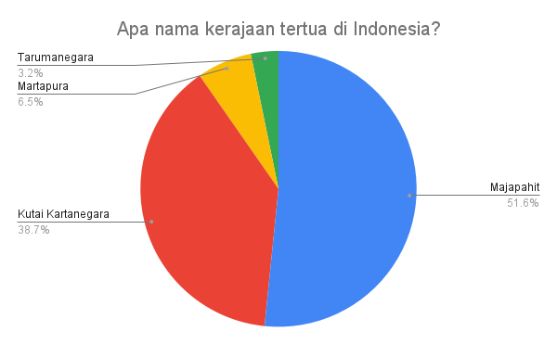
Figure 1 Pie diagram of the oldest royal questionnaire in Indonesia

The results of the second questionnaire questioned the legacy of the oldest kingdom in Indonesia, namely the Kingdom of Martapura. The results of the screening obtained data as much as 61.3% of students answered Borobudur Temple as a relic of the Martapura Kingdom, 22.6% of students answered the Tugu Inscription, 9.7% of students answered 7 Yupa pieces, and 6.5% answered Tikus Temple. The second questionnaire question, which is the legacy of the oldest kingdom, namely Martapura, is 7 Yupa inscriptions. The depiction of this percentage can be seen in Figure 2 below.

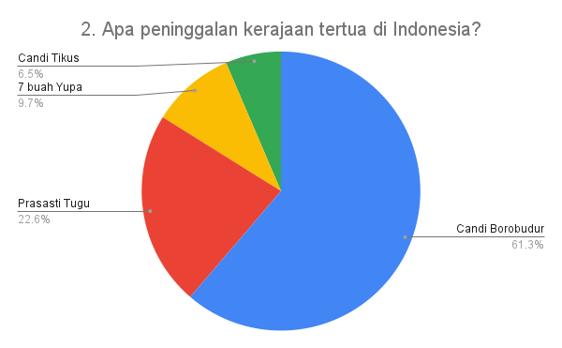
Figure 2. Pie chart of the oldest royal heritage

The third questionnaire collects data on questions about the first king of the oldest kingdom in Indonesia. The results of the questionnaire were 71% answering King Mulawarman, 12.9% answering King Aswawarman and Kundungga, and 3.2% answering King Purnawarman. The right answer to this question is King Kundungga as the first king of the oldest kingdom in Indonesia. An illustration of the explanation above can be seen in Figure 3 of the pie chart below.
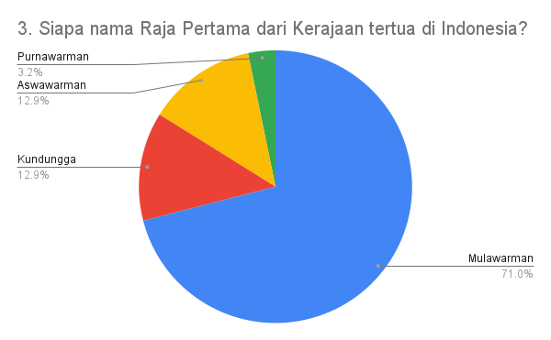
Figure 3. Pie chart of the first king of the oldest kingdom in Indonesia

The fourth question captures data about the location of the Martapura kingdom as the oldest kingdom in Indonesia. The results of the questionnaire showed that 35.5% of students said Tenggarong, 32.3% of students answered in Trowulan, East Java, 16.1% of students answered on Citarum Riverside, and 16.1% of students answered in Muara Kaman, East Kalimantan. The correct answer to this questionnaire has a low percentage of 16.1%, namely in Muara Kaman, East Klaimantan. The description of the questionnaire can be seen in Figure 4 below.

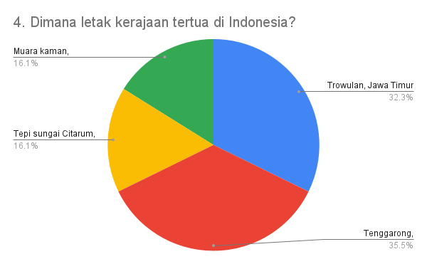
Figure 4 Pie chart of the oldest kingdoms in Indonesia

Question five points descriptively shows students do not know the figure of King Mulawarman. From the open questions on the questionnaire, the majority of students mistakenly said the figure of King Mulawarman. The students should have called King Mulawarman the third king of the Martapura kingdom who brought prosperity to the kingdom. King Mulawarman as the son of King Aswawarman and grandson of King Kundungga.
Questionnaire point 6 presents questions with answer options where students can choose more than one answer. The choice of this answer is directed at capturing variations in answers about what media are used by teachers in teaching Mathematics in SD. The results of the questionnaire showed that 13 students answered the teacher using video, 11 students answered the teacher used teaching aids, 11 students answered the teacher used power point, 11 students answered the teacher used the android application, 4 students answered the teacher did not use teaching media, 4 students answered the teacher used the website, and 3 students answered the teacher using voice recordings. This description can be seen in Figure 5 of the bar chart below.

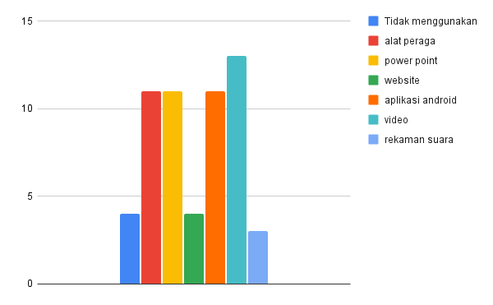
Figure 5. A bar chart of the media questionnaire used by the teacher during the learning process

The seventh questionnaire captures data that has various student answer options. Questionnaire questions related to which internet-based media are used to teach Mathematics by teachers. The results of the questionnaire showed that 32.6% of students received internet-based mathematics teaching through YouTube video media, 26.1% of students received whatshapp internet-based mathematics teaching, 21.7% of students received application internet-based mathematics teaching, 10.9% of students received mathematics teaching internet-based websites, 6.5% of students receive internet-based Mathematics teaching on Instagram videos, and 2.2% of students receive tiktok video internet-based Mathematics teaching. An overview of this point can be seen in Figure 6 below.

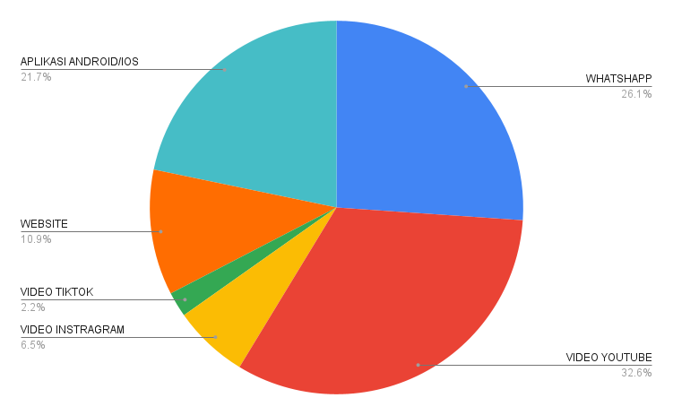
Figure 6 Pie diagram of the media questionnaire used by the teacher in learning Mathematics

The eighth questionnaire question is about student choices related to teaching Mathematics in class. Questionnaire answers may be chosen by more than one student. The results of the questionnaire found that 33.3% of students liked learning Mathematics with videos, 19.3% of students liked learning Mathematics with visual aids, 17.5% of students liked learning Mathematics with powerpoint, 15.8% of students liked learning Mathematics with android applications, 7% of students like learning Mathematics with audio recordings, and 7% of students like learning Mathematics with websites. This description can be seen in Figure 7 of the pie chart below
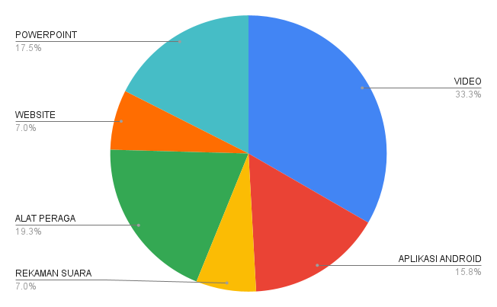
Figure 7 Pie diagram of student's choice questionnaire related to Mathematics teaching media

The ninth questionnaire is related to the learning process of Mathematics in student classes with teachers using the Android application. The results of the questionnaire show that the majority of students and Mathematics teachers in elementary schools have never used Android-based applications for learning. The percentage values ​​are translated, namely 61.3% of students have never used an android application for learning Mathematics with the teacher, and 38.7% of students stated that they had used an android-based application for learning Mathematics with the teacher. This image can be seen in Figure 8 below.

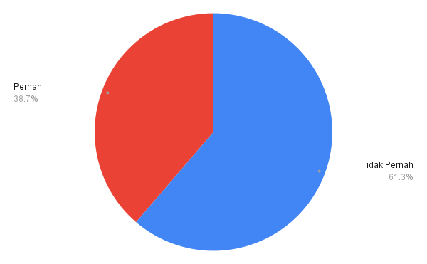
Figure 8 pie chart questionnaire about students and teachers using android applications in learning Mathematics

The tenth point of the questionnaire captures data on Mathematics teaching linked to History-Culture (Ethnomatematics). more precisely, the questionnaire question, namely, have you ever studied Mathematics related to history or culture in Indonesia? This question is an important part of research studies. The results of the questionnaire showed that 61.3% of students had never studied Mathematics in relation to History or Culture (ethnomatematics) in Indonesia, and 38.7% of students had studied Mathematics in connection with History or Culture (ethnomatematics) in Indonesia. The results of this percentage can be described in the pie chart in Figure 9 below.
Figure 9 Questionnaire pie chart on ethnomathematics-based Mathematics teaching

The eleventh questionnaire questions capture data related to students' likes and reasons. The feeling of liking and the reasons for this are related to the questionnaire questions. Do you like learning History lessons? The results of the questionnaire showed that 74.2% of students liked History, 19.4% of students said it was normal, and 6.5% of students said they did not like it. The three answers to the questionnaire have in common that all students do not give reasons related to the choice of answer points. Furthermore, from the results of the questionnaire, it can be seen that the tendency of students to like History lessons. The results of the questionnaire can be seen in Figure 10 below.

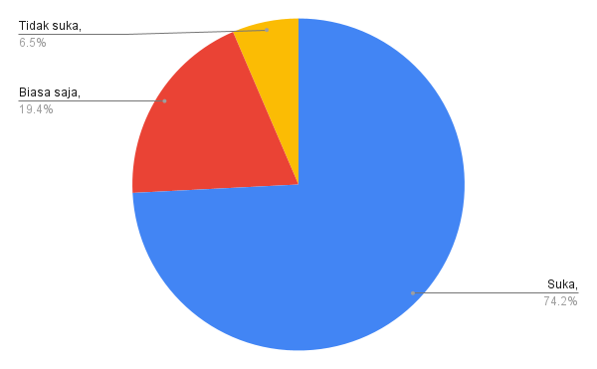
Figure 10 Questionnaire pie chart about history subject preferences

The twelfth point of the questionnaire relates to students' preferences in choosing a way to study history. Questionnaire is that you prefer to learn history lessons in a way? The results of the questionnaire showed that 34.8% of students liked learning history by reading, 34.8% of students liked learning history by listening, and 30.4% of students liked learning history by watching movies or videos. The results of the questionnaire can be seen in Figure 11 below.

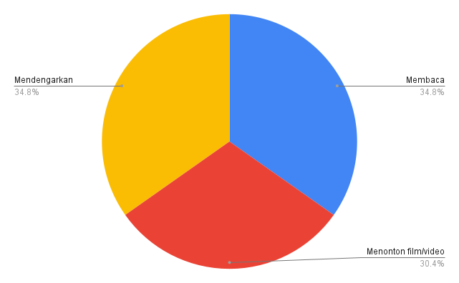
Figure 11 Questionnaire pie chart on how students learn history

The thirteenth questionnaire question points relate to student ownership of gadgets or cellphones. Ownership of a device or cellphone is related to the core of this development research, namely the existence of technological tools used for learning. The results of the questionnaire stated that 65.2% of students in elementary schools had gadgets/mobile phones, and 34.8% of students in elementary schools did not have gadgets/cell phones. The results of the questionnaire can be seen in Figure 12 below.
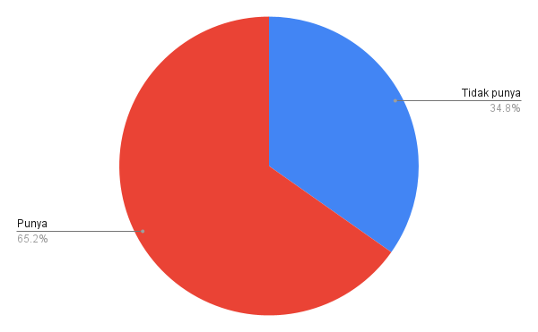
Figure 12 Pie diagram of a student questionnaire regarding device/mobile phone ownership

The fourteenth questionnaire relates to the use of devices/cell phones. The questionnaire question is what do you use your gadget/mobile phone for more often? The results of the questionnaire show that 45.8% of students use gadgets/mobile phones for online games/games, 20.8% use them for social media, 12.5% for communication, 12.5% for study, and 8.3% for study. as well as social media. An overview of the questionnaire can be seen in Figure 13 below

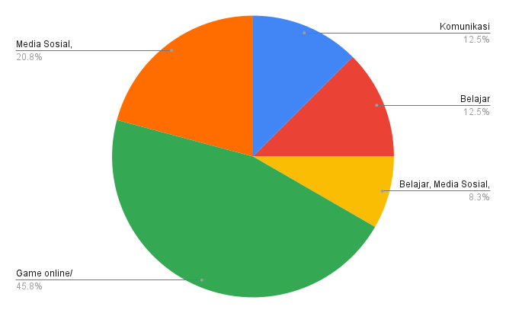
Figure 13 Pie chart about the gadget/mobile phone usage questionnaire

The final questionnaire in this study relates to the duration of students using gadgets/mobile phones. By asking the question, how many hours a day do you use your cell phone in total? The results of the questionnaire show that 70.8% of students use gadgets/mobile phones for 2-4 hours in one day, 20.8% of students use gadgets/mobile phones for 4-6 hours in one day, and 8.3% of students use gadgets/mobile phones for more than 6 hours in one day. This description can be seen in Figure 14 below.

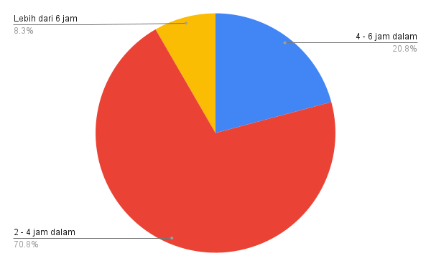
Figure 14 Questionnaire pie chart about the length of time you use your device/mobile phone

Obtaining data from the interview aspect obtained descriptive data that has similarities with the results of the questionnaire. The results of the interviews were conducted with teachers of grades 4 and 6 or high grades at SD. The interviews in general show similarities to the questionnaire which discusses the learning media from the teacher. PowerPoint media is a media that is often used by teachers in teaching. The learning process in the classroom has not used internet-based media. This internet-based media is used on Android devices or cellphones. Besides that, the results of interviews with teachers also showed findings that in learning Mathematics it has not been linked to the discussion of History-Culture or known as Ethnomatematics.

- Design (Desain)
The second stage in the ADDIE model development research is in the form of teaching material development design or the Design stage. The design of the development from scratch is based on the results of the previous student needs analysis. The design process involves multidisciplinary knowledge from Mathematics and History. The two disciplines are combined in the form of android-based teaching materials with the help of the I Spring Suite application.
The design process begins with creating a narrative concept that describes the history of the Martapura Kingdom with King Mulawarman who brought wealth and prosperity. The narration is equipped with numeration content, especially the introduction of ancient numbers. Kurniawan (2023) this ancient number comes from the Yupa inscription from codes D.2a, D.2b, D.176, and D.177. These ancient numbers are then presented in written form in teaching media accompanied by an interesting narrative. The narration accompanying the images is voiced by the user by pressing the speaker symbol on the media display. This description can be seen in Figure 15 below.

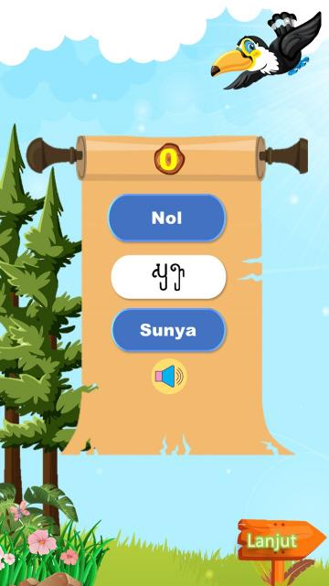

Figure 15. Display I of Spring Suite with payload of ancient numbers

The second process is to design an illustration image that fits the narrative prepared. This illustration is illustrated with ten scenes depicting ancient numerical and numeric content. All of these illustrations are adopted from the translation of the Yupa inscription. The translation used for this illustration is like the story of King Aswawarman having three sons with the most prominent being King Mulawarman. In another story, King Mulawarman donated a number of cows to Brahmins. This narrative can be seen in Figure 16 below.

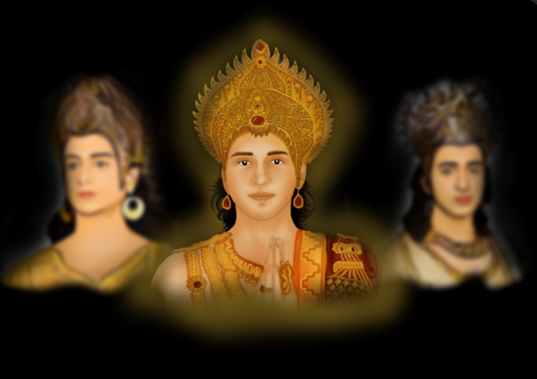
Figure 16. Yupa code D.2a with the inscription "Sang Aswawarman has three sons, like three (holy) fires. The foremost of the three sons is the Mulawarman, a king who is well civilized, strong and powerful”.

The design of the third stage of development is to obtain a compilation of media or mathematics teaching materials with an ethnomathematics theme. This ethnomathematics theme was introduced as a form of student literacy in understanding the concept of numbers. The concept of numbers in this research is in the form of ancient numbers written in Sanskrit Pallawa script. Presentation of teaching materials at the end is added evaluation questions to measure students' understanding after studying the media. The evaluation questions consist of 10 questions consisting of five questions with historical content and five questions with mathematical concepts. The results of the development design can be seen in Figure 17 below.

Figure 17. Initial display set of I Spring Suite, Learning objectives, and four icons for learning
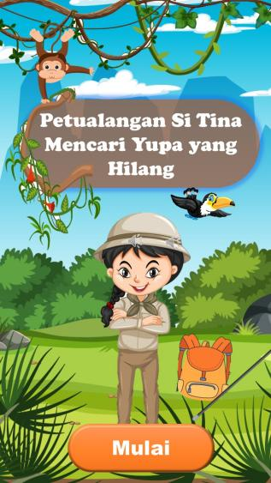
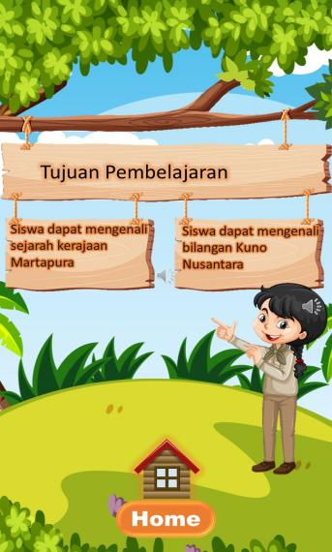
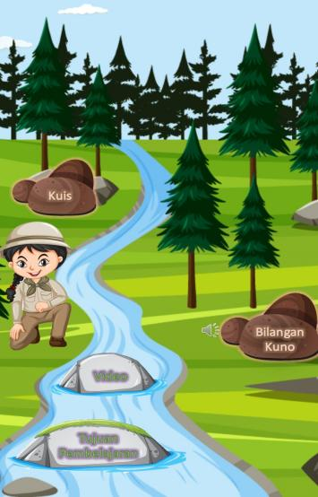

Discussion
Based on the research results obtained from quantitative and qualitative data. Quantitative data is in the form of a questionnaire that is presented. Furthermore, qualitative data comes from interviews to validate the results of the questionnaire. The analysis is carried out by looking directly at the needs of the learning media that will be developed by the researcher. The data is then used as a reference to determine the things needed in the process of developing teaching materials. The development of this teaching material relates to Android-based Martapura Kingdom numeration with the help of the I-Spring Suite for elementary school students in Samarinda City.
The first stage of developing the ADDIE model is analysis or needs analysis in the form of a questionnaire analysis. The results of the questionnaire for points number 1 to 5 are related to students' knowledge of the theme of History. The results of the questionnaire showed that first the students did not know that the oldest kingdom in Indonesia was Martapura, the two students chose the wrong archaeological heritage building from the Martapura Kingdom, the three students said the first king of the Martapura Kingdom, the fourth student did not understand the exact location of the Martapura Kingdom site, the fifth majority of students do not know the exact figure of King Mulawarman.
This low student knowledge is due to low literacy related to historical reading materials. The low percentage of research results is one of the initial footholds in the analysis of needs for the development of teaching materials. It is necessary to package historical themed teaching materials to motivate students in learning. This is in accordance with Uno (2007) that the important role of motivation in learning and learning, among others, is in (a) determining things that can be used as reinforcement in learning, (b) clarifying learning objectives to be achieved, (c) determining various kinds of control over learning stimuli, (d) determining persistence in learning.
The need for the latest innovative learning media is felt necessary today. This need is seen from two aspects, namely the needs of teachers and students. According to Basri and Sumargono (2018) media is useful for teachers to concretize material concepts and motivate students. Aspects of students with the use of learning media will help to think critically. These two things become one unit that cannot be separated. The unity of these components then leads to the achievement of learning competencies.
The process of achieving learning competencies in this study is presented with the help of technology-based media. With the existence of technology can increase motivation to learn students. Thus, learning mathematics with an ethnomathematics theme can be presented attractively with the help of an application. Daryanto in Ashar (2021) and strengthening strategies to increase student learning motivation in the form of using audiovisual-based learning media, in which students are directly involved in the learning process by seeing and hearing directly learning material shown through short videos, historical films and documentaries.
The results of the questionnaire on question numbers 6 to 15 regarding the use of media in learning Mathematics at SD. The results of the questionnaire with the highest percentage showed that 33.3% of students liked learning Mathematics with videos, 61.3% of students had never used the Android application for learning Mathematics with the teacher, 61.3% of students had never studied Mathematics related to History or Culture ( ethnomathematics) in Indonesia, 74.2% of students like history lessons, 34.8% of students like learning history by reading, 34.8% of students like learning history by listening, and 30.4% of students like learning history by watching movies or videos, 65.2% of students in elementary schools have gadgets/mobile phones, 45.8% of students use gadgets/mobile phones for online games/games, 70.8% of students use gadgets/cellphones for 2-4 hours in one day.
Hasil rekap data angket dari hasil tertinggi tersebut menggambarkan bahwa siswa menyukai guru selama proses pembelajaran Matematika menggunakan media yang menarik. Sesuai dengan analisis kebutuhan juga menunjukkan masih terbatasnya penggunaan aplikasi dalam pembelajaran Matematika. Aplikasi terkini seperti I Spring Suite belum banyak digunakan. Apalikasi ini terhubung internet berbasis android. Sejalan dengan ini Riyan (2021) menguatkan bahwa peningkatan mutu kualitas pendidikan bisa dilakukan dengan pemanfaatan teknologi melalui penciptaan aplikasi pembelajaran berbasis android oleh guru-guru atau penggiat pendidikan yang dapat menarik minat peserta didik dalam kegiatan pembelajaran.
The second stage in this development research is the design stage. The design stage in this development becomes part of the ADDIE model. The design or design of this development is prepared through several stages. The first stage is compiling narrative images according to the text of the Yupa inscription. The second stage is designing the storyline with accompanying voice narration. The third stage is combining images and sound through the I Spring Suite application which is then installed on an Android device or cellphone.
The design of this teaching material is arranged with illustrations of historical events from the Yupa Inscription. The pictures are depicted in an interesting way and are in accordance with the elementary school level. The suitability of the pictures with the story line can motivate students in learning about ancient numbers. Dewi et al (2018) concluded that there are three benefits of image-illustrated media-assisted learning, namely; Caricature image media enhances aspects of cognitive motives, aspects of self-expression, and aspects of self enhancement.

CONCLUSION
The results of the research and discussion can be concluded that the majority of students' understanding of the profile of the Kingdom of Martapura is still low. Ethnomatematics-based Mathematics learning needs to be conveyed to support students' understanding of the History-Culture-based Mathematics teaching materials. In addition, the use of internet media based on android applications for learning Mathematics in Elementary Schools needs to be developed to increase student interest and motivation

REFERENCE
Ashar, Andi Aziz. 2021. Application of Audiovisual Learning Media in Increasing the Learning Motivation of Class XI.IPS 1 Students in History Subjects at SMA Negeri 7 Wajo. Bachelor thesis, State University of Makassar.
Basri, M. and Sumargono. 2018. Historical Learning Media. Yogyakarta: Science Graha
Dewi, Annisa et al. 2018. The Effectiveness of Using Caricature Images on Increasing Student Learning Motivation in History Subjects. EDUTCEHNOLOGIA, Year 2, Vol 2 No. 1, pp. 1-12
Kemp, Simon. Digital 2022: Indonesia. 15 February 2022. datareportal.com/reports/digital-2022-indonesia
Kharisma, Giri Indra. 2020. The Effect of Android-Based Learning Media on the Ability to Understand Procedural Texts of Grade VII Students. LEARNING LANGUAGES: Scientific Journal of Indonesian Language and Literature Education Study Program. Vol. 5 No. 2 (2020), 269-278, DOI: https://doi.org/10.32528/bb.v5i2.2795
Kurniawan et al. 2023. Number of Yupa Inscribed Stones of the Kingdom of Martapura in Kutai, East Kalimantan. Samarinda: Pustaka Horizon
Muchtar, F. Y., Nasrah, N., & Ilham S, M. (2021). Development of Interactive Multimedia Based on I-Spring Presenter to Improve Critical Thinking Skills of Elementary School Students. Basicedu Journal, 5(6), 5520–5529
Ryan, M. 2021. Use of Android Application-Based Learning Media in Expositional Text Learning. Journal: diction Volume 29, Number 2, doi: 10.21831/diksi.v29i2.36614
Setianugraha & Subagio. 2019. Development of I-Spring Learning Media in Science Subject Material for Identifying Various Class IV Elementary School Styles. PGSD Journal Volume 8 Number 6, pp. 1078-188
Uno, H. B. 2007. Theory of Motivation & Its Measurement. Jakarta: PT Bumi Aksara.

