Historical Entrepreneurship Program Development (Historiopreneurship) in Samarinda City and Kutai Kartanegara

Reza ¹⁾, Vitria Puri Rahayu ²⁾, Christie Stephanie Piar ³⁾. Dwi Atmono ⁴⁾, Muhammad Rahmatullah ⁵⁾, Nurliyana ⁶⁾
¹²³⁶⁾Mulawarman University, Samarinda, Indonesia
⁴⁵⁾Mulawarman University, Samarinda, Indonesia

¹⁾reza_pendeko79@yahoo.co.id

ABSTRACT

These ancient mosques, both located in Samarinda and Tenggarong, are relics of the Islamic community in the past where the location around the mosque besides being a center for worship and development of Islamic religion. The existence of ancient relics in the form of old mosques which have cultural and religious values ​​should ideally be preserved to develop Islamic symbols. Apart from that, it can be a place for religious tourism education in East Borneo. The purpose of this research is to identify the potential for historical entrepreneurship in the cities of Samarinda and Tenggarong, as well as to analyze the need for historical entrepreneurship programs in universities in Samarinda and Tenggarong. The research approach uses a qualitative approach. Research using historical methods. Data collection was carried out by observation and interview techniques. The results of the research show that cultural heritage that has historical value can become the religious center of the surrounding community and pave the way to become a center of economic activity that produces an entrepreneurial community. The research findings show that the strategic location of historical places can make the surrounding community more creative in maximizing economic potential in entrepreneurship. The implications of further research are expected to be used to develop entrepreneurship programs in universities based on local wisdom in East Borneo.
Keyword: History, Enterpreneurship, Historiopreneurship

INTRODUCTION
Tourism is one of the strategic assets to encourage national development for a country's economic growth. Research by Kristo and Yunita Sopiana (2020) states that an increase in tourists visiting tourist attraction areas has led to an increase in the income of people who sell in tourist attraction areas so that the welfare of the people around the tourist attraction areas also increases. The potential for tourism based on cultural history is one of the assets that has the potential to be developed by each region (Adi, et al., 2013 dan 2014).
The historical value contained in the tourist area is what historical tourism objects offer. Some of these tourist objects are building architecture, culture and past beliefs (Ishak, 2020). The spread of Islam in the city of Samarinda cannot be separated from the existence of the Shirathal Mustaqim mosque which is the forerunner to the founding of the city of Samarinda (Rullia, 2013, Azmi, 2021). However, since the establishment of the Samarinda Islamic Center complex, which also stands on the banks of the Mahakam River on a different side, it seems to have become a new magnet for marking the city of Samarinda. This causes concern about the sustainability of one of the historical charms of religious tourism in the city of Samarinda. These ancient mosques, both located in Samarinda and Tenggarong, are relics of the Islamic community in the past where the location around the mosque besides being a center for worship and development of Islamic religion. The existence of ancient relics in the form of old mosques which have cultural and religious values ​​should ideally be preserved to develop Islamic symbols. Apart from that, it can be a place for religious tourism education in East Borneo.
The facts on the ground is the packaging of historical tourism products is less attractive, until now there are still no superior tourism products. There needs to be the development of tourism products that describe the uniqueness itself The low level of socialization and utilization of tourist facilities that have historical tourism potential (Azmi, 2018). The definition of tourism according to A.J Burkat in Damanik (2006), tourism is the movement of people temporarily and in the short term to destinations outside the places where they usually live and work and also their activities while living in a destination. According to Mathieson & Wall in Pitana and Gyatri (2005), tourism is an activity of temporarily moving people to destinations outside their residence and place of work and carrying out activities while at the destination as well as preparing facilities to meet their needs.
Entrepreneurship is a science that examines the development and development of a creative spirit and the courage to take risks in the work that is done
carried out in order to realize the results of the work (Fahmi, 2014). The courage to take risks already belongs to an entrepreneur because he is required to be brave and ready if the business undertaken does not yet have the value of attention in the market. The role of an entrepreneur according to Suryana has two roles, namely as an inventor and as a planner. As an entrepreneurial inventor discovers and creates new products, new technologies and ways, new ideas and new business organizations. As planners, entrepreneurs play a role in designing new businesses, planning new corporate strategies, planning ideas and opportunities within the company.
Entrepreneurship is a combination of creativity, innovation and courage to face risks that are carried out by working hard to form and maintain new businesses (Suryana, 2014). Historiopreneurship is an effort to optimize entrepreneurial fields that are oriented towards historical themes (Sodiq and Suharso: 2017).

RESEARCH METHODS
The research approach uses a qualitative approach. This type of research is historical. Data collection techniques are observation and interviews. The stages of research include Data reduction, Data display, and Conclusion/ verification

RESULTS AND DISCUSSION
Results

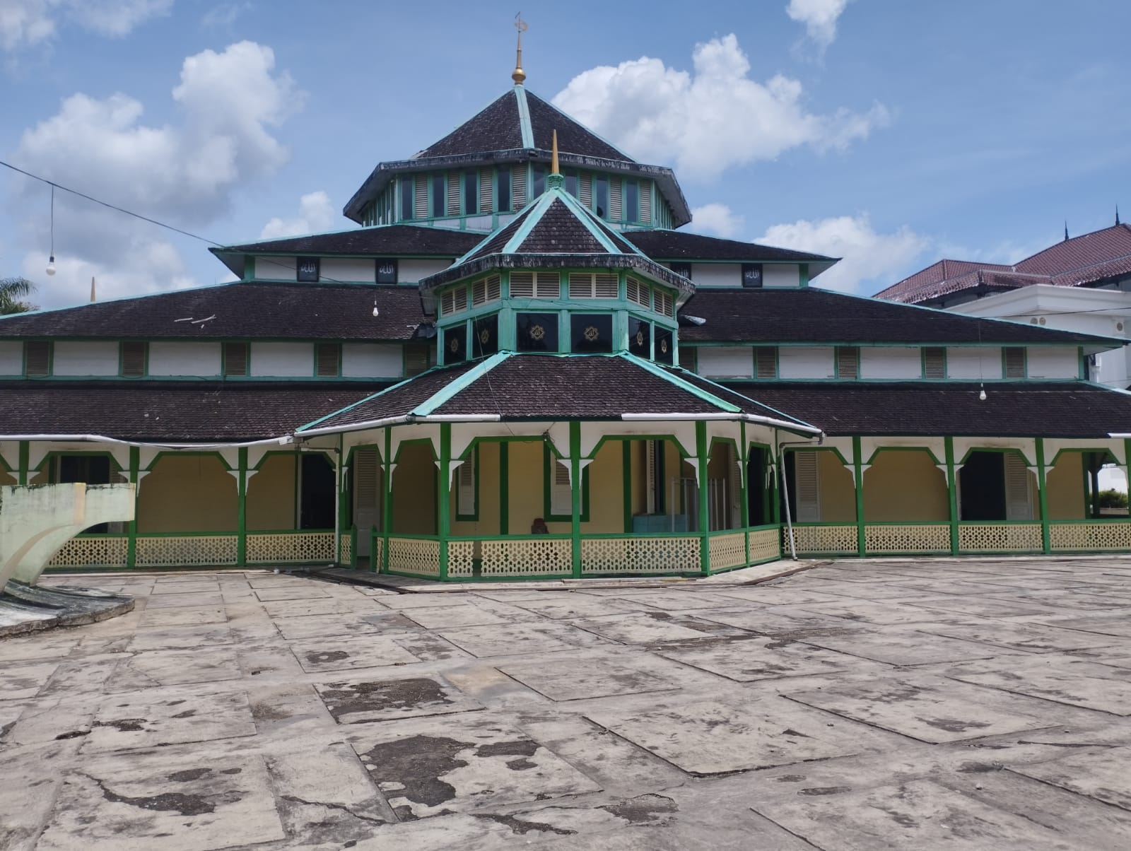
Picture 1. Masjid Jami’Adji Amir Hasanuddin
Source: Data processed (2022)
The legacy of the Kutai Sultanate which never changed form. The building is one and a half centuries old. Mutual cooperation was built by the people and scholars. Established in the style of local houses and Malay Cultural influences in 1930. There is only one person selling merchandise in the form of packaged drinks. Most sellers prefer around the new mosque which is in front of the old mosque.
The advantages of the Jami' Adji Amir Mosque are that the prayer room is neatly and cleanly maintained and a large parking lot in the courtyard of the mosque. It has a lot of access entrances, namely as many as nineteen doors. Excellent ventilation so that air can flow freely making it comfortable to worship in the mosque. But the drawback is that there are no road signs to the location of the Jami' Adji Amir Hasanuddin Mosque.

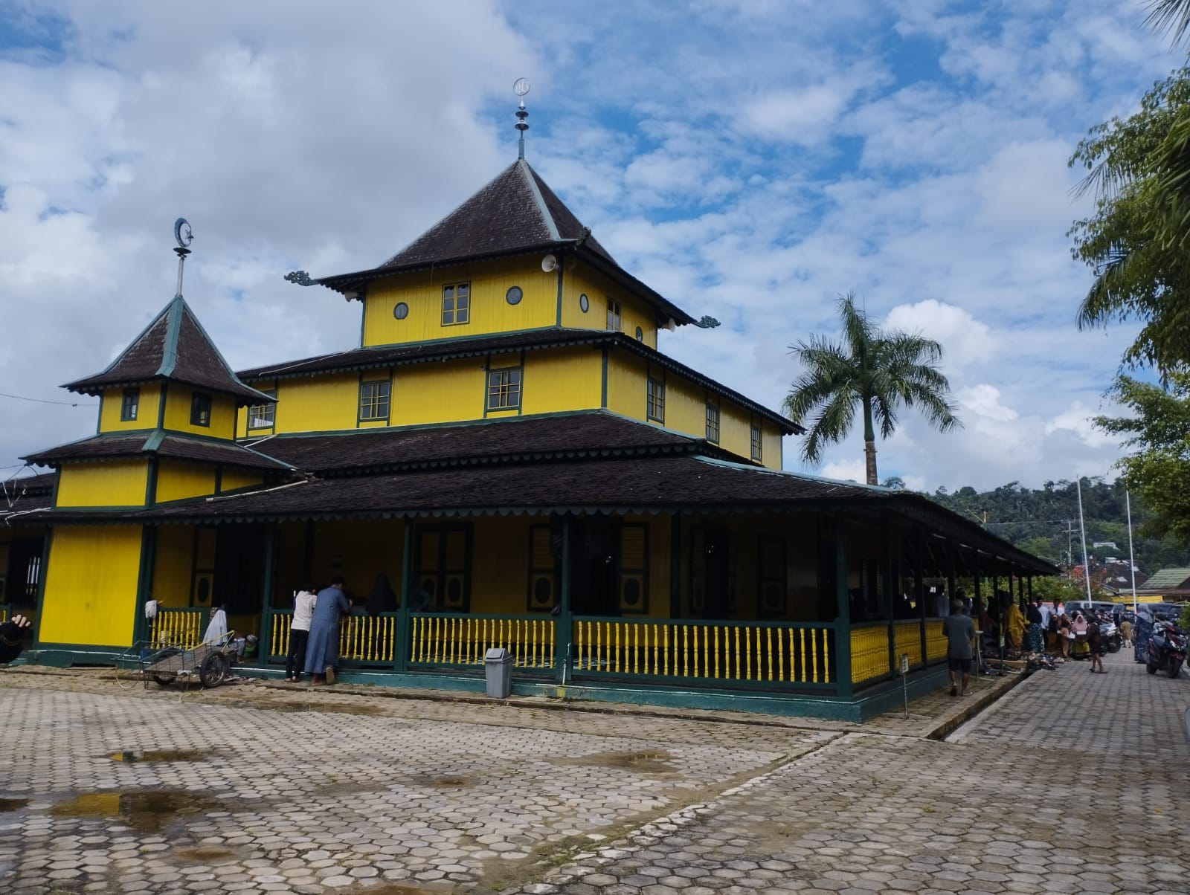
Picture 2. Masjid Shiratal Mustaqiem
Source: Data processed (2022)
Shiratal Mustaqiem Mosque is the oldest mosque in Samarinda City. The mosque, which was built in 1881, was the 2nd winner in the Festival of historic mosques in Indonesia in 2003. Currently, the Shirathal Mustaqiem mosque functions well, both as a place of worship and as a popular religious tourist spot in Samarinda City. The community around the old mosque takes advantage of the mosque's activity situation by developing entrepreneurship. Along the left side and in front of the old mosque, local people have used it for entrepreneurship.
The advantages of Shiratal Mustaqiem are that the prayer room is neatly and cleanly maintained and a large parking area is in the courtyard of the mosque. Having several access doors so that air can flow freely makes it comfortable to worship in the mosque. The facilities owned by the mosque are very complete so that they can meet the needs of the community or mosque visitors. But the drawback is that there are no road signs to the location of the Shiratal Mustaqiem Mosque.
Discussion
The Jami'Adji Amir Hasanuddin Mosque and the Shiratal Mustaqiem Mosque are two cultural heritages in East Borneo that must be preserved so they are timeless. The historical values contained in the two old mosques are part of the values of the struggle of the people in the past which were embodied in the form of places of worship. The historical value contained in it makes the two mosques still function properly today. People routinely use it to carry out the five daily prayers and major religious events. The historical value contained in it makes the two mosques still function properly today. People routinely use it to carry out the five daily prayers and major religious events.
Cultural heritage that has historical value if well developed will strengthen the local economic potential. There are differences between the old mosques in the two research locations. The old mosque in Samarinda Seberang has more visitors and entrepreneurial people compared to Kutai Kartanegara. Interestingly, all residents who live along the road in front of the Shiratal Mustaqiem mosque develop an entrepreneurial spirit by opening businesses that meet the complete needs of the community, starting from grocery stores, food stalls, motorcycle repair shops, pharmacies, barber shops, photo printing businesses, to clothing rental businesses. bridal and salon. This makes the Shiratal Mustaqiem mosque area seem to be the center of activity and commerce for the Samarinda Seberang community.

CONCLUSION
The description of the potential of historical tourism objects in Samarinda City and Kutai Kartanegara Regency consists of 4 aspects, namely Attractions, Facilities, Accessibility and services, namely:
- In the aspect of attractions, historical tourist attractions in Samarinda City and Kutai Kartanegara Regency are buildings that are hundreds of years old and ancient building architecture that has its own uniqueness.
- In terms of facilities, historical tourism in Samarinda City and Kutai Kartanegara Regency has mostly been managed or assisted by the government and facilities in all historical tourism objects are quite complete, namely there are parking lots, toilets and secretarial rooms.
- In terms of accessibility, historical tourism in Samarinda City and Kutai Kartanegara Regency is divided into two, namely through land and river water transportation.
- In terms of service, around tourist objects, most of them are stalls or restaurants that can be found. Meanwhile, hotels or inns can only be found in the city center.

REFERENCES
Adhitya, W., Bayu, K., & Morina, S. G. (2019). Dampak Sektor Pariwisata Terhadap Pertumbuhan Eknomi ( TLG Hipotesis, Studi Kasus : 8 Negara ASEAN). E-Jurnal Ekonomi dan Bisnis Universitas Udayana, 1193-1208.
As'ad, M. (2013). Masjid Tua Shirathal Mustaqiem Samarinda: Fenomena Dahsyatnya Kekuatan Spiritual. Jurnal Penelitian Agama Dan Sosial Budaya.Vol.19, No.2.
Asisten Deputi Pengembangan Wisata Budaya Deputi Bidang Pengembangan Industri dan Kelembagaan Kementerian Pariwisata. (2019). Pedoman Pengembangan Wisata Sejarah dan Warisan Budaya. Jakarta Selatan: Gedung Film Pesona Indonesia.
Azmi, M. (2018). Using Historical Sites in East Kalimantan for Education: Challenges and Opportunities. Yupa: Historical Studies Journal, 2(1), 71-80.
Azmi, M. (2021). Islamisasi di Bumi Etam: Transformasi Politik, Agama dan Budaya Masyarakat Kutai. Langgong: Jurnal Ilmu Sosial dan Humaniora, 1(2), 91-105.
Gibson, C. (2015). Negotiating Regional Creative Economic :Academics as Expert Intermediaries Advocating Progressive Alternative. Journal of Regional Studies, 476-479.
Irdika, I. W. (2007). Pusaka Budaya dan Pariwisata . Pustaka Larasan.
Irham, F. (2014). Kewirausahaan Toeri, Kasus dan Solusi. Bandung: Alfabeta.
Jamal, M., bustami, & Desma, R. (n.d.). Kebudayaan dan Wisata Sejarah : Exsistensi Obyek Sejarah Terhadap Perkembangan Wisata di Pariangan kabupaten Tanah Datar. Jurnal Sejarah dan Kebudayaan.
Kristo, & Yunita, s. (2020). Analisis Dampak Sektor Pariwisata terhadap Kesejahteraan Pedagang di Kota Samarinda. Jurnal Ilmu Ekonomi dan Pembangunan, 551-559.
Mukhsin, D. (2014) Strategi Pengembangan Kawasan Pariwisata . Jurnal pengembangan Wilayah dan Kota, Vol.14, No.1.
Muslim, A. (2015). Morfologi Masjid Kuno Aji Amir Hasanuddin Tenggarong Kutai Kartanegara. Jurnal Penelitian Agama Dan Sosial Budaya. Volume 21, No.1.
Rullia. (2013). Masjid Shirathal Mustaqim, Pesona Pusaka Arsitektur Tropis di Tepi Sungai Mahakam. Temu Ilmiah IPLBI.
Rusdiana. (2014). Kewirausahaan Teori dan Praktik. Bandung: CV Pustaka Setia
Sodiq & Suharso. (2017). Historiopreneurship: Optimalisasi Industri Kreatif Bertema Sejarah di Sekitar Kampus.Jurnal Abdimas, Vo.21, No.2.
Sukamdani, S. G. (2013). Wirausaha Berbasis Islam & Kebudayaan. Jakarta: Pustaka Bisnis Indonesia.
Sulistiono, B. (2013). Seminar Hasil Penelitian Rumah Ibadah Bersejarah di Provinsi Kalimantan Timur. Balitdiklat Kemenag RI.
Suryana. (2014). Kewirausahaan Kiat dan Proses Menuju Sukses, Jakarta: Salemba Empat.
Suyatmin, W. A., & Edy, P. S. (2017). Perkembangan Konsep dan Riset E-Busniess di Indonesia 744 Potensi Daya Tarik Wisata Sejarah Budaya. Seminar Nasional Riset Manajemen & Bisnis.
Yakup, A. P. (2019). Pengaruh Sektor Pariwisata terhadap pertumbuhan Ekonomi Di Indonesia.
Yoeti, O. (2006). Pariwisata Budaya Masalah dan Solusinya. Jakarta: PT Pradnya Paramita.

